<Possible Dashboards>
- Neighborhood Safety Dashboard:
  - Maps highlighting crime density and safer neighborhoods.
  - Filters for crime type, time, and season.
- Visitor Safety Dashboard:
  - Heatmaps showing safer times and common crime types near tourist destinations.
- Business Insights Dashboard:
  - Bar charts and trendlines showing safe operating hours and crime proximity to businesses.

1. Temporal Analysis: Safer Times for Visiting

- Time-of-Day and Day-of-Week Analysis of Crime Rates (Heatmap) with Primary Description as a Filter
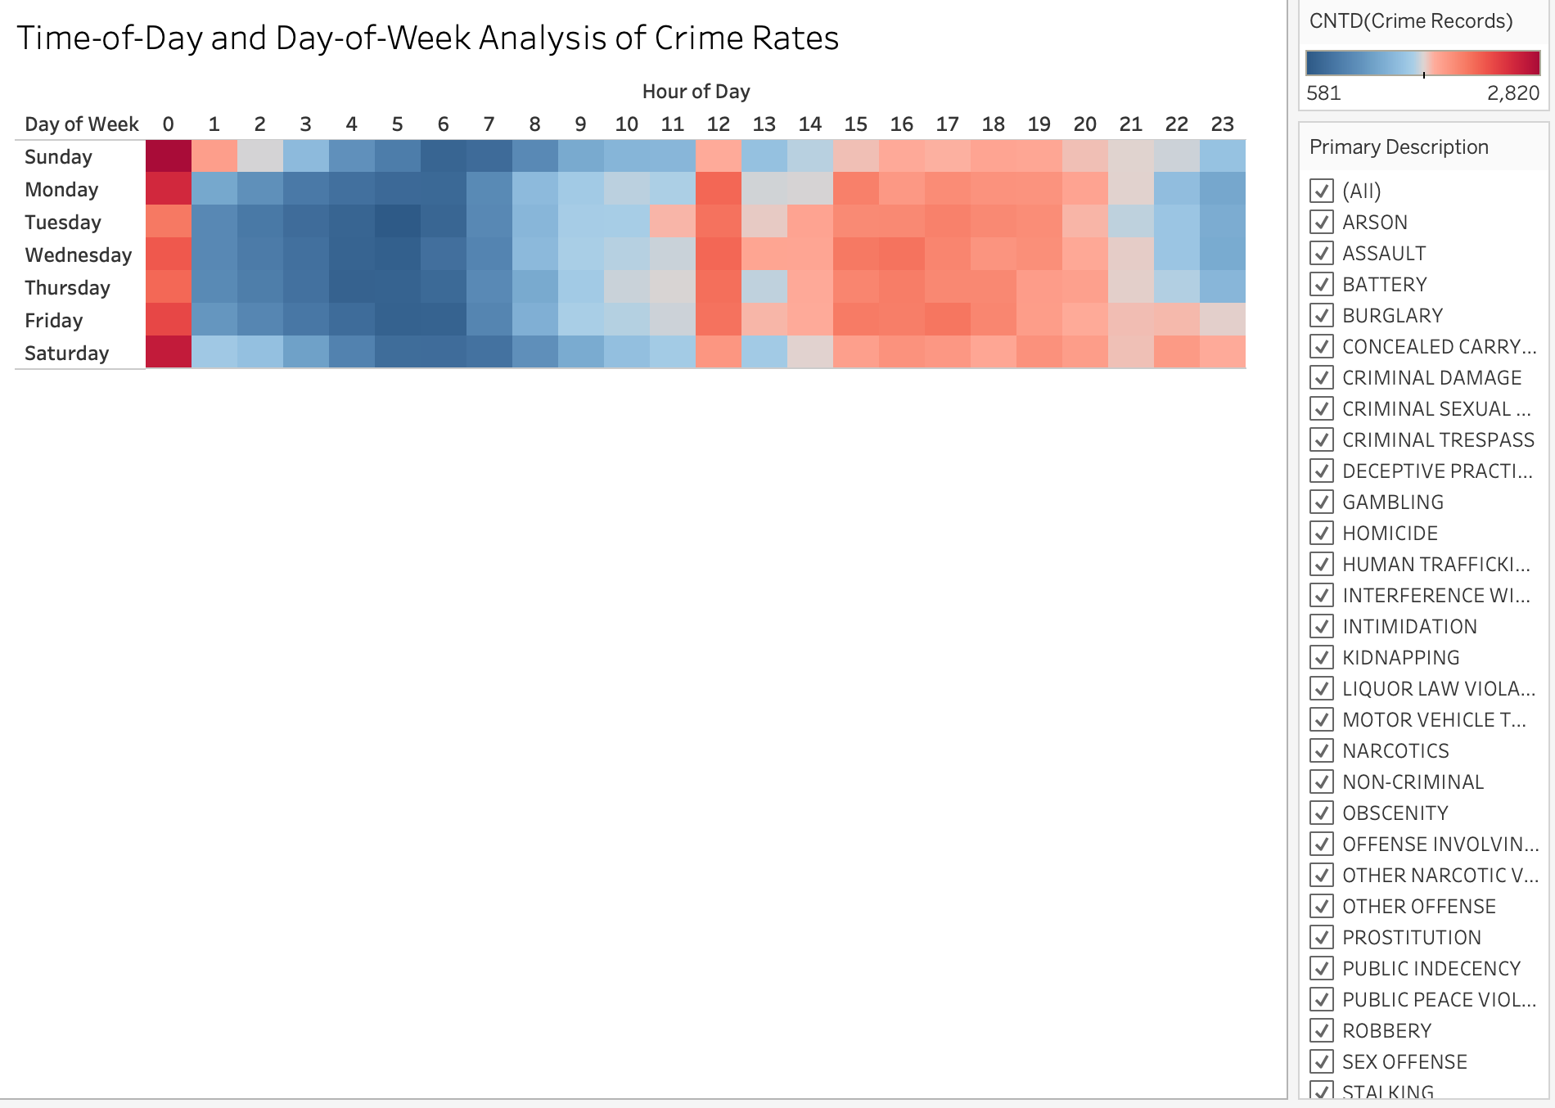

- Date of Occurrence vs Number of Crimes (Line Chart)
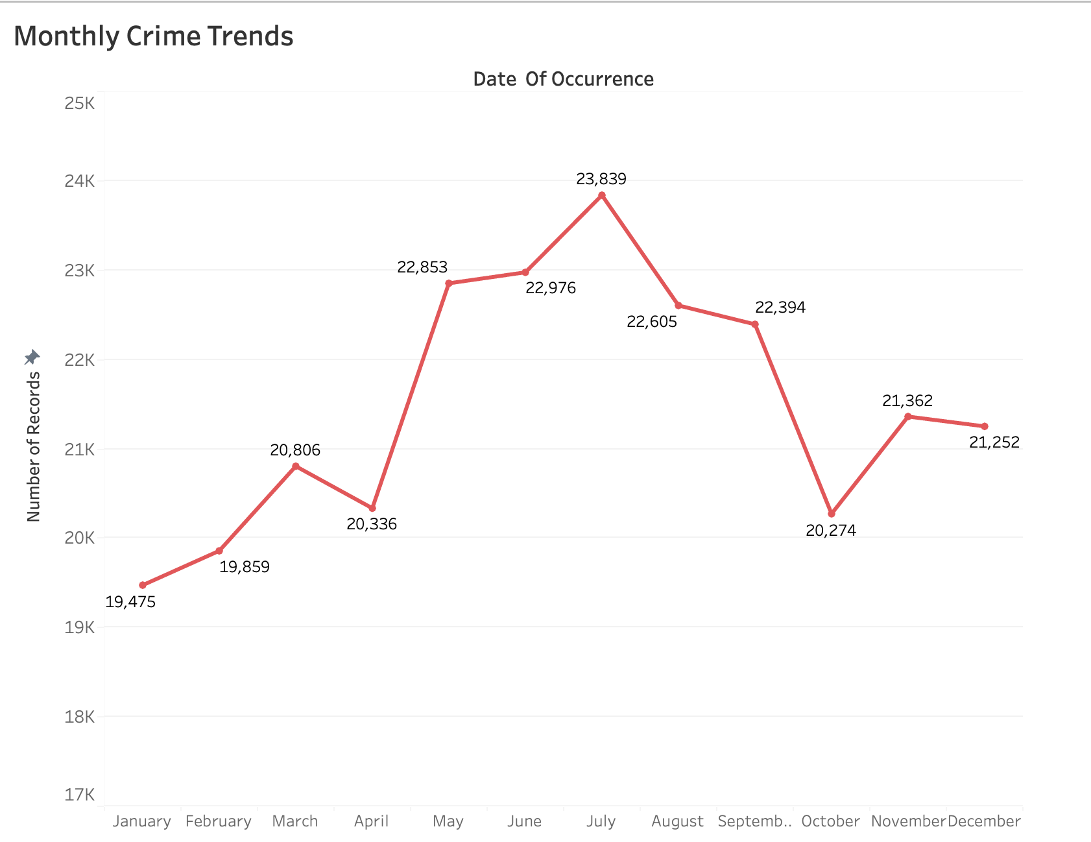

2. Geographic Analysis: Mapping Crime Incidents by Neighborhood
- Geographic Analysis of Crime Density Including Crime Category (Map)
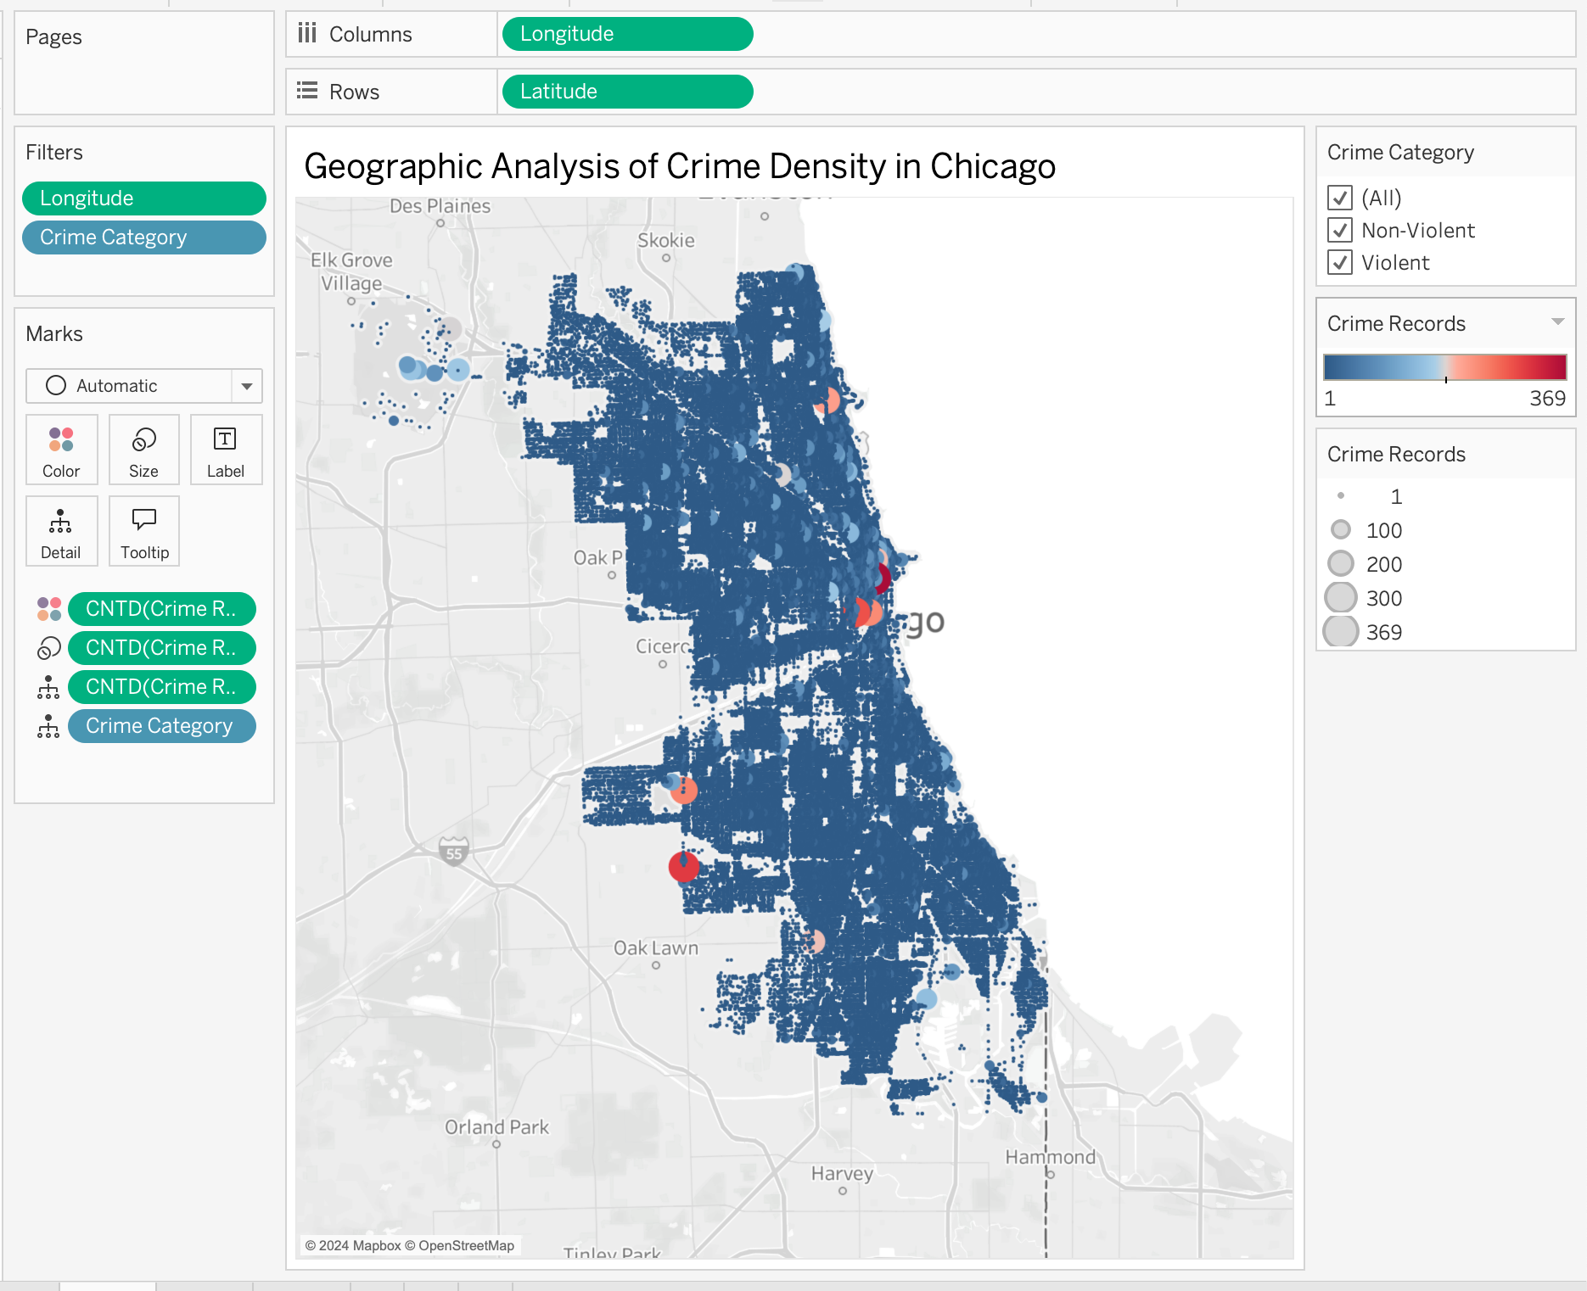

- Crime Types by Community in Chicago (Highlight Table)
  - We could consider to just include Top 10 Crime types & Top 10 Community Areas with most crimes
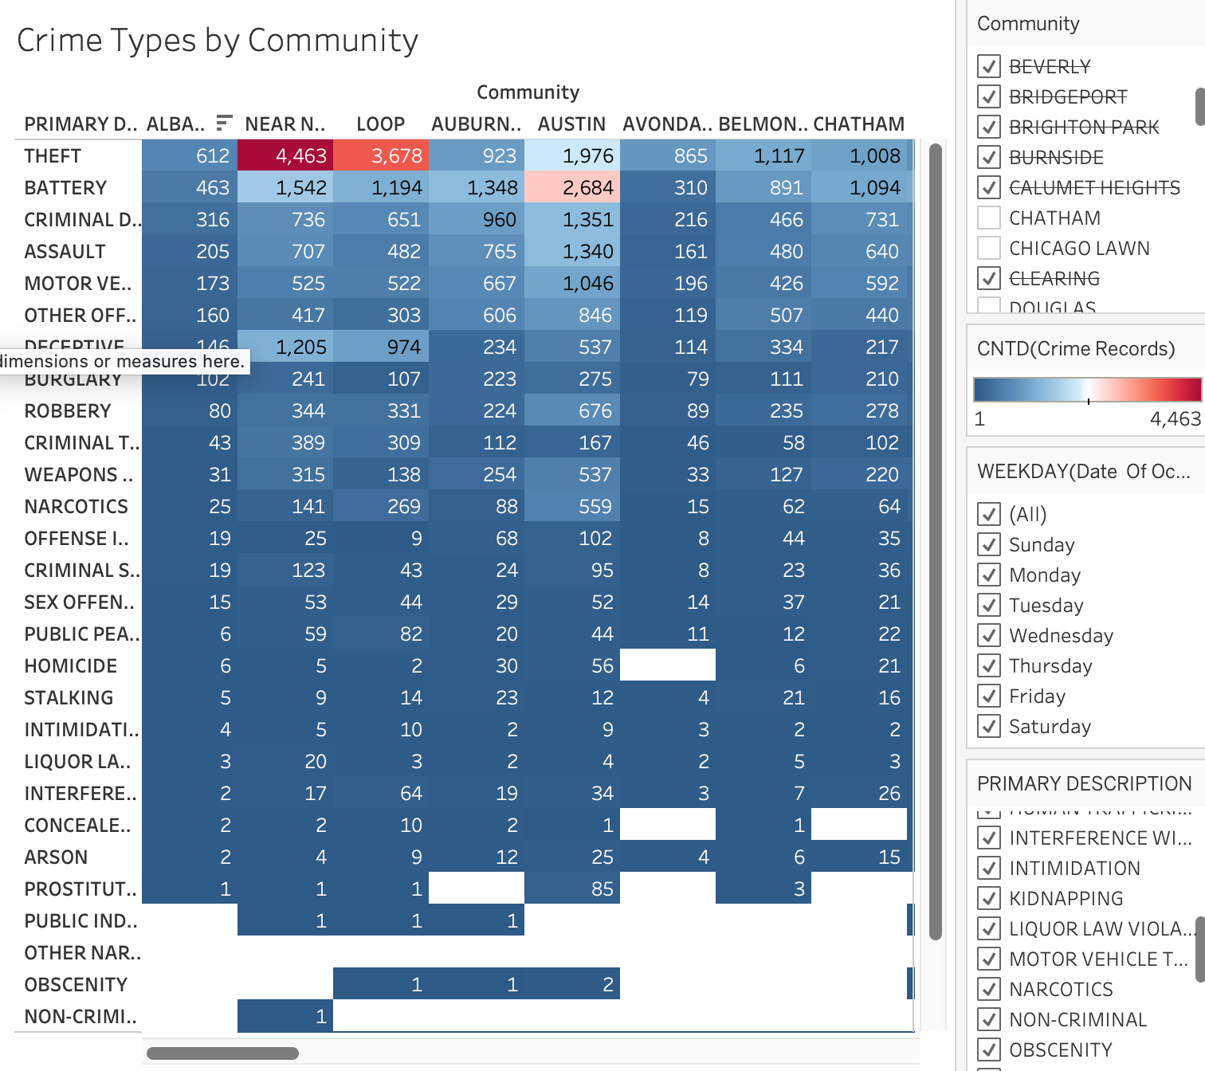

3. Crime Type Analysis: Common Incidents in Tourist Areas
a. Number of Crimes vs Primary Description (Bar Chart)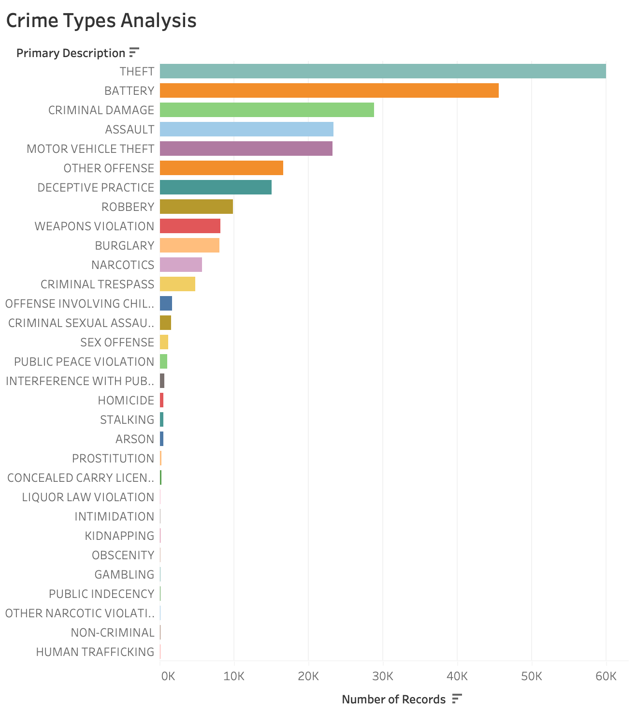

4. Number of Crimes by Community Areas in Chicago (Bar Chart)
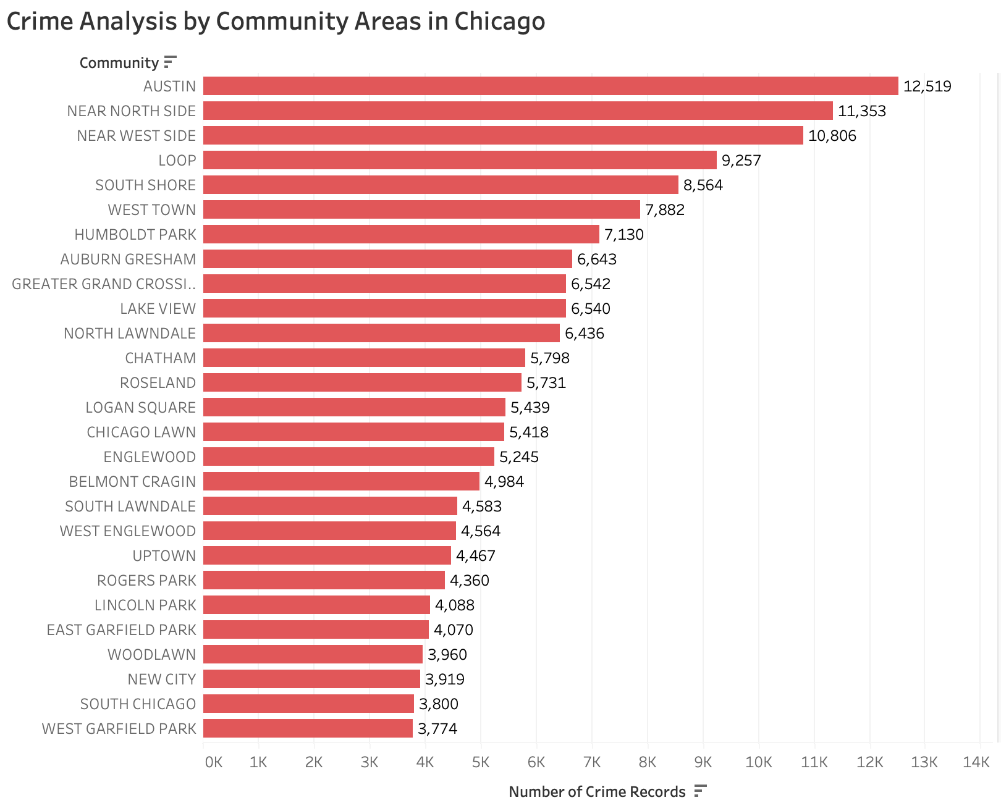

<Possible EDA>

1. Spatio-Temporal Patterns
- Visualization: Dual-Axis Maps with Time Layers
  - Combine crime density maps with time filters (e.g., day/night, weekday/weekend) to see how hotspots change throughout the day or week.
  - Overlay specific crime types or categories (e.g., violent vs. non-violent) on top of the base map.
- Visualization: Time-Animated Maps
  - Use Tableau’s Pages feature to animate crime density over time (e.g., monthly or quarterly shifts in crime hotspots).
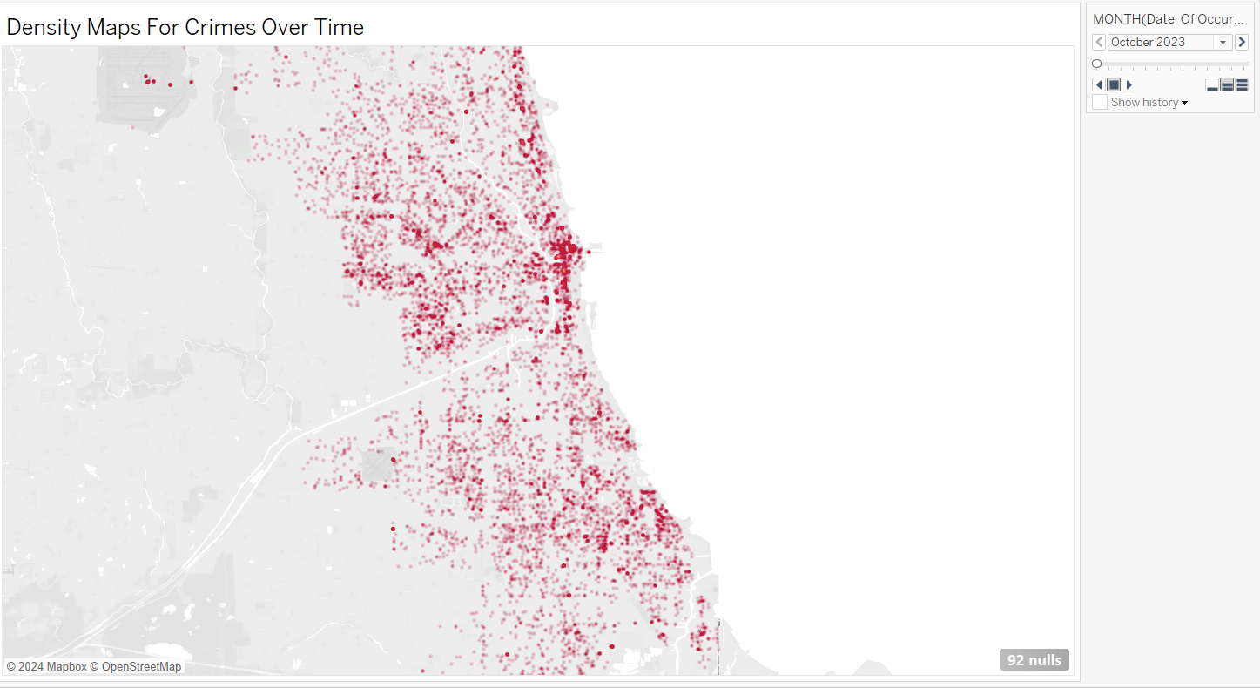
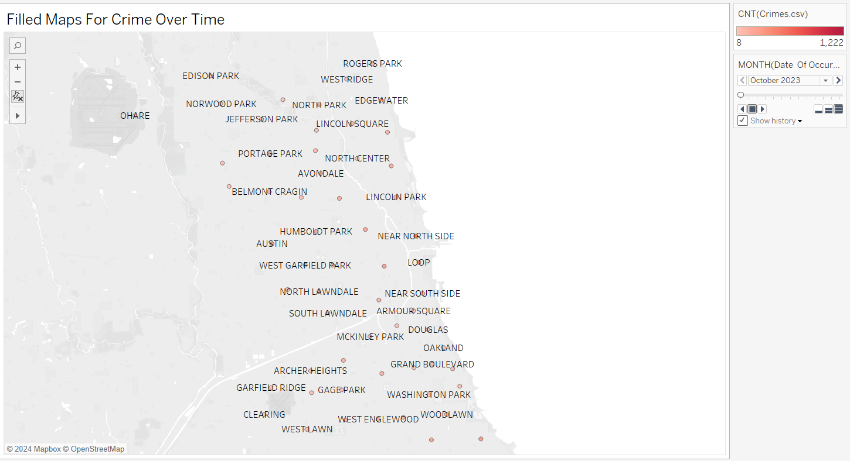

2. Crime Evolution Over Time
- Visualization: Line Charts by Primary Description
  - Track trends for specific crime types (e.g., theft, robbery) over time (weekly, monthly, yearly).
  - Compare multiple crime types on the same chart to identify patterns.
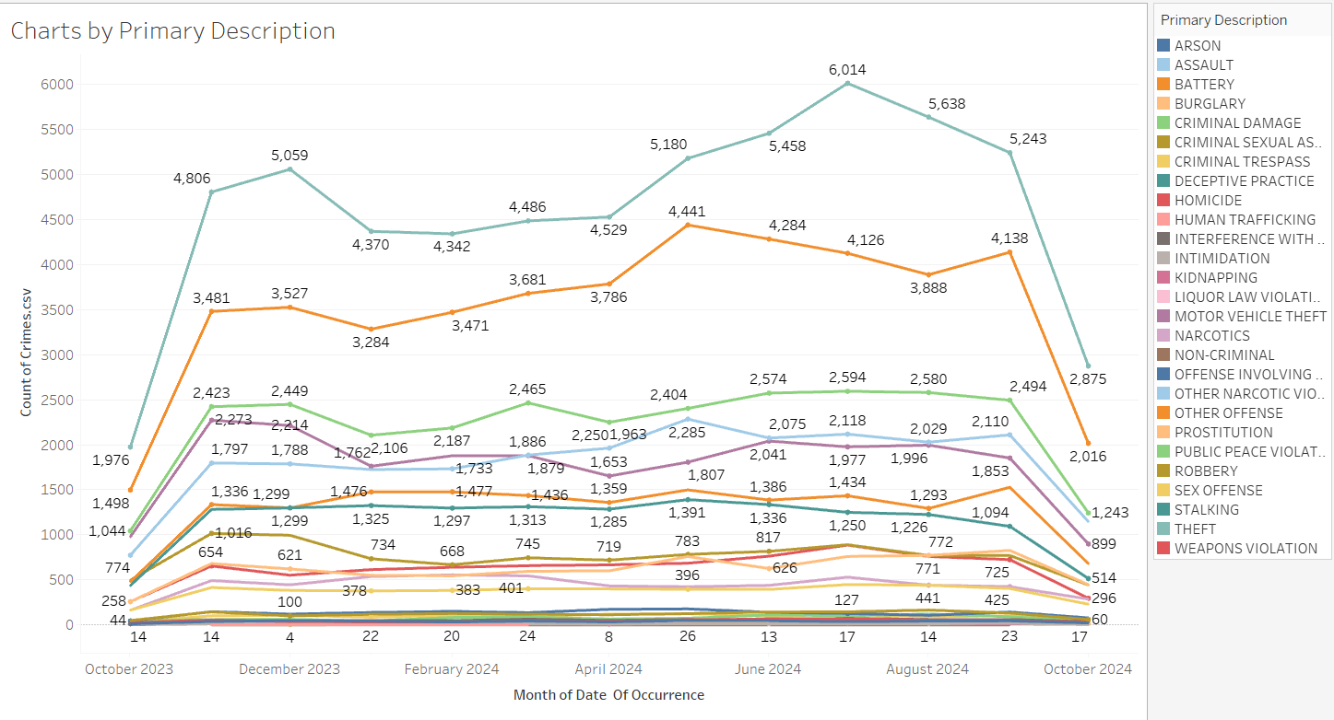
- Visualization: Area Charts
  - Show cumulative crime counts over time to understand overall trends.

3. Crime Correlations
- Visualization: Scatter Plots
  - Explore relationships between different variables, such as:
    - SHAPE_AREA (neighborhood size) and crime frequency.
    - Socioeconomic factors (e.g., income levels) and crime rates if external data is available.
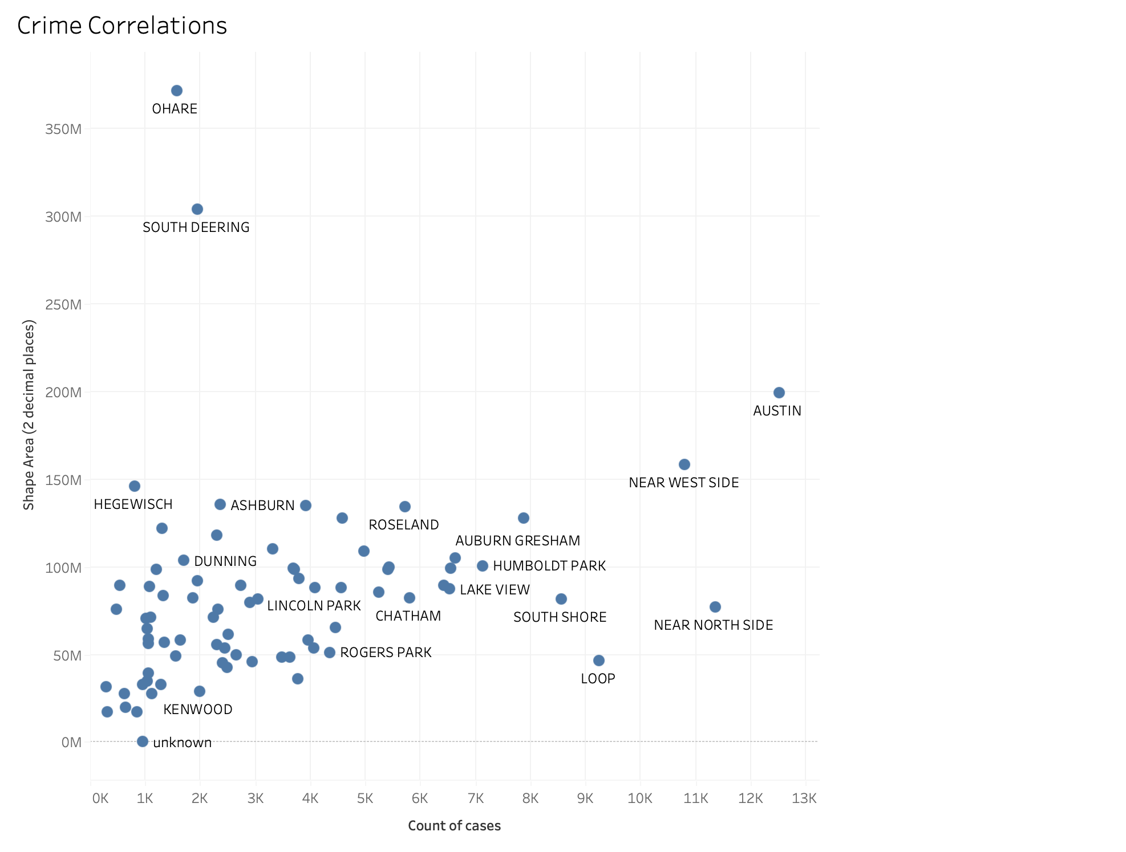
- Visualization: Heatmaps for Correlations
  - Create heatmaps to display correlations between crime types, time, location, and socioeconomic indicators.

4. Detailed Temporal Analysis
- Visualization: Highlight Tables for Hourly Trends
  - Show crime frequency for each hour of the day, broken down by days of the week or months.
- Visualization: Bump Charts
  - Rank crime types over time (e.g., see if theft consistently ranks highest or other crimes emerge during specific periods).

5. Community Safety Rankings
- Visualization: Tree Maps
  - Rank communities or neighborhoods by crime frequency, color-coded by crime types.
- Visualization: Bar and Line Combo Chart
  - Compare crime trends in the top 5 communities with the highest crime counts.

6. Incident Severity Analysis
- Visualization: Box Plots
  - Analyze the severity of crimes (based on IUCR codes or violent/non-violent classification) across neighborhoods.
- Visualization: Histogram
  - Show the distribution of crimes by severity levels or arrest likelihood.

7. Repeat Crime Locations
- Visualization: Density Maps for Specific Locations
  - Identify repeat crime locations by plotting LOCATION DESCRIPTION data (e.g., incidents at train stations, alleys, or retail stores).

8. Arrest Rate Analysis
- Visualization: Bar Chart with Arrest Proportions
  - Compare arrest rates across crime types to identify which crimes have higher resolution rates.
- Visualization: Pie Chart
  - Show the proportion of incidents that lead to arrests versus those that do not.

9. Seasonal Trends
- Visualization: Line Chart with Monthly Averages
  - Identify how crime fluctuates seasonally (e.g., spikes in summer or holiday-related crimes).
- Visualization: Calendar Heatmaps
  - Create a heatmap for each day of the year to identify specific dates with unusual crime activity.

10. Crime Predictability
- Visualization: Forecast Charts
  - Use Tableau’s forecasting feature to predict crime trends for upcoming months.
- Visualization: Cluster Analysis
  - Apply clustering to group similar crime-prone neighborhoods based on variables like crime type, frequency, and time.

11. Socioeconomic Context (if External Data Available)
- Visualization: Bubble Charts by Socioeconomic Factors
  - Plot crime counts against indicators like unemployment rates, median income, or education levels.
- Visualization: Dual-Axis Charts
  - Compare crime frequency with socioeconomic trends over time (e.g., unemployment vs. crime rate).

12. Analysis of Specific Crime Types
- Visualization: Stacked Area Chart
  - Track the relative contribution of different crime types to overall crime trends over time.
- Visualization: Word Clouds
  - Use text data (like Secondary Description) to visualize frequently occurring phrases associated with certain crime types.

13. Crime Categorization by Location
- Visualization: Stacked Bar Chart by Location Description
  - Compare crime types across different locations (e.g., streets, parks, schools).
- Visualization: Pie Charts for Popular Locations
  - Show crime proportions at high-incidence locations.

14. Comparative Analysis
- Visualization: Side-by-Side Bar Charts
  - Compare crime rates in tourist vs. non-tourist areas.
- Visualization: Slope Graphs
  - Show changes in crime frequency or type rankings over two time periods (e.g., pre-pandemic vs. post-pandemic).

15. Interactive Dashboards
- Combine Multiple Visualizations:
  - Geographic maps for hotspots.
  - Temporal heatmaps for peak times.
  - Bar charts ranking crime types or communities.
- Add Filters:
  - Enable users to filter by time, location, crime type, or severity.

